TASK 1 : a) 4-bit moore sequence detector (FSM)(with overlapping)

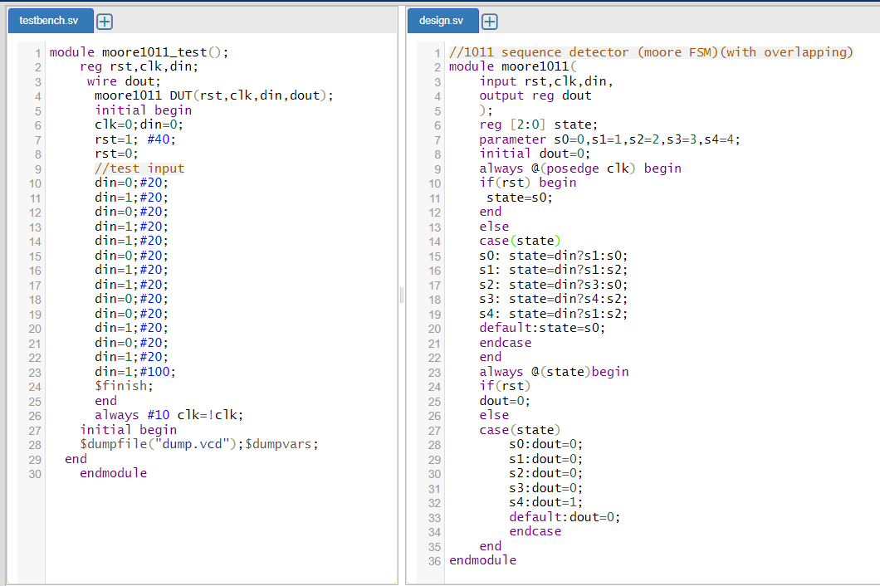

OUTPUT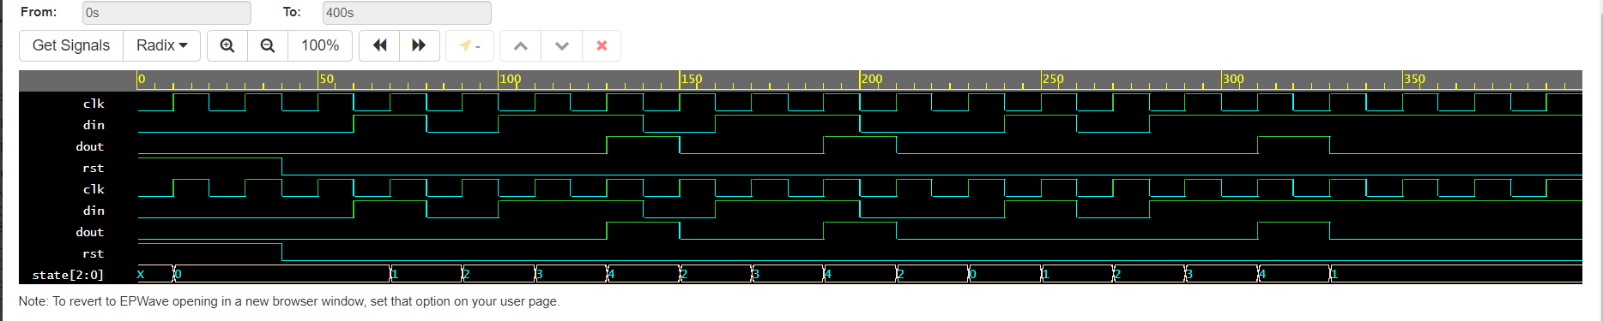

b) 4-bit mealy sequence detector (FSM)(with overlapping)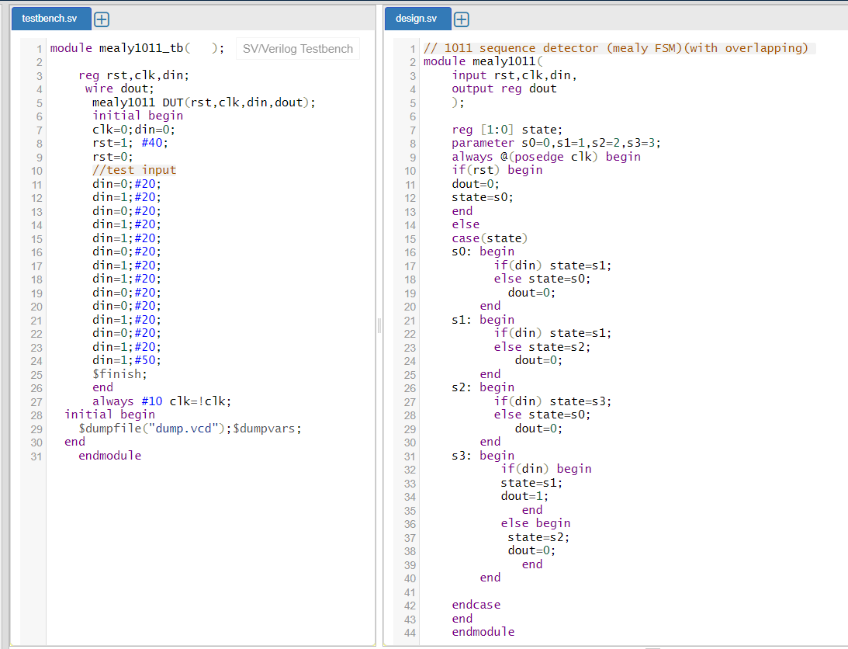

OUTPUT

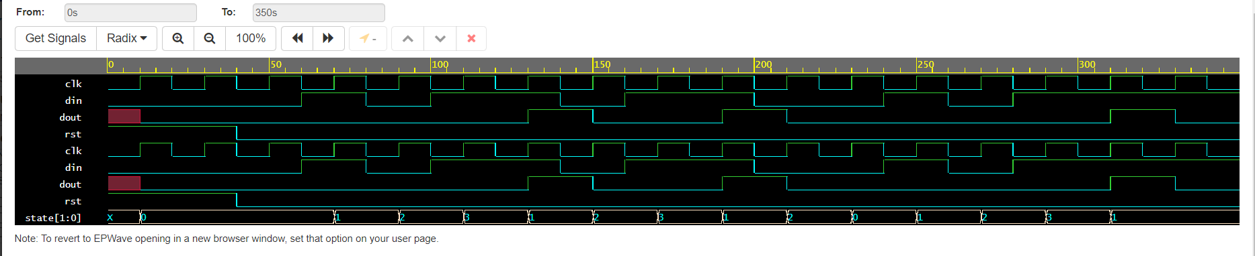

TASK 2 : mod-7 up/down counter

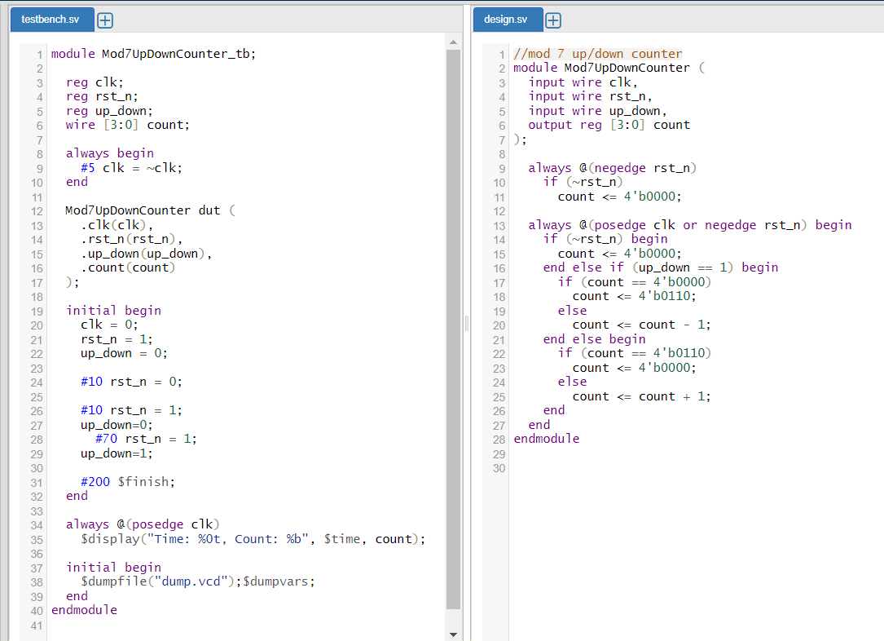

OUTPUT

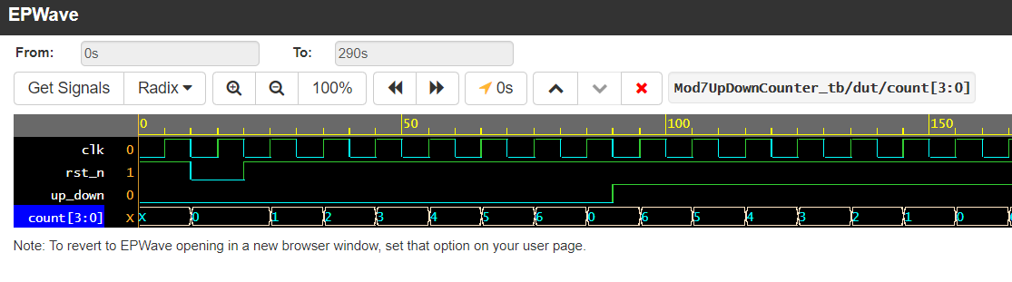

TASK 3: 4-bit even parity generator

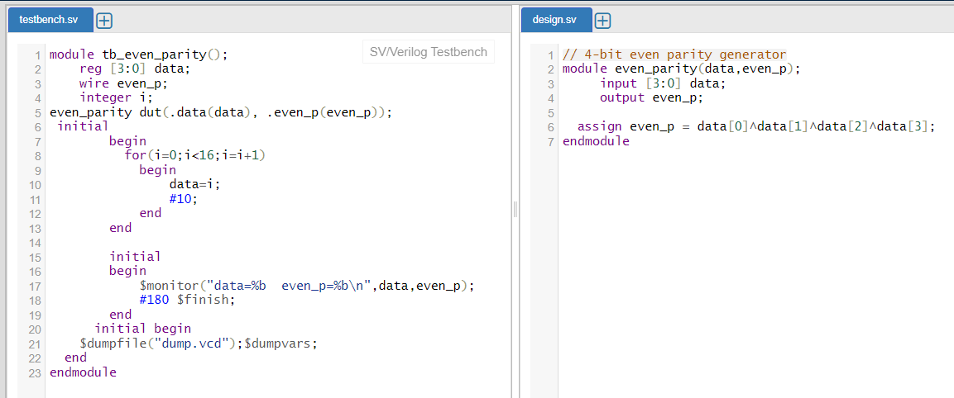

OUTPUT

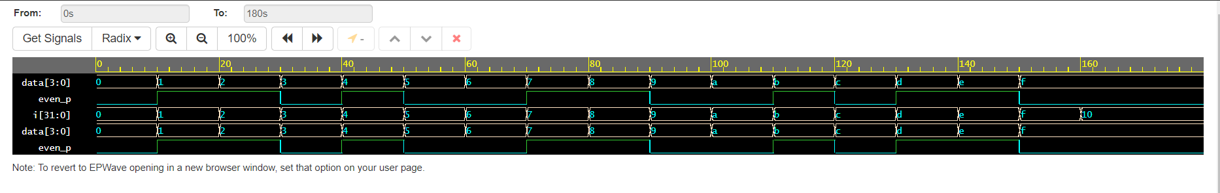

TASK 4 : 4 bit multiplier

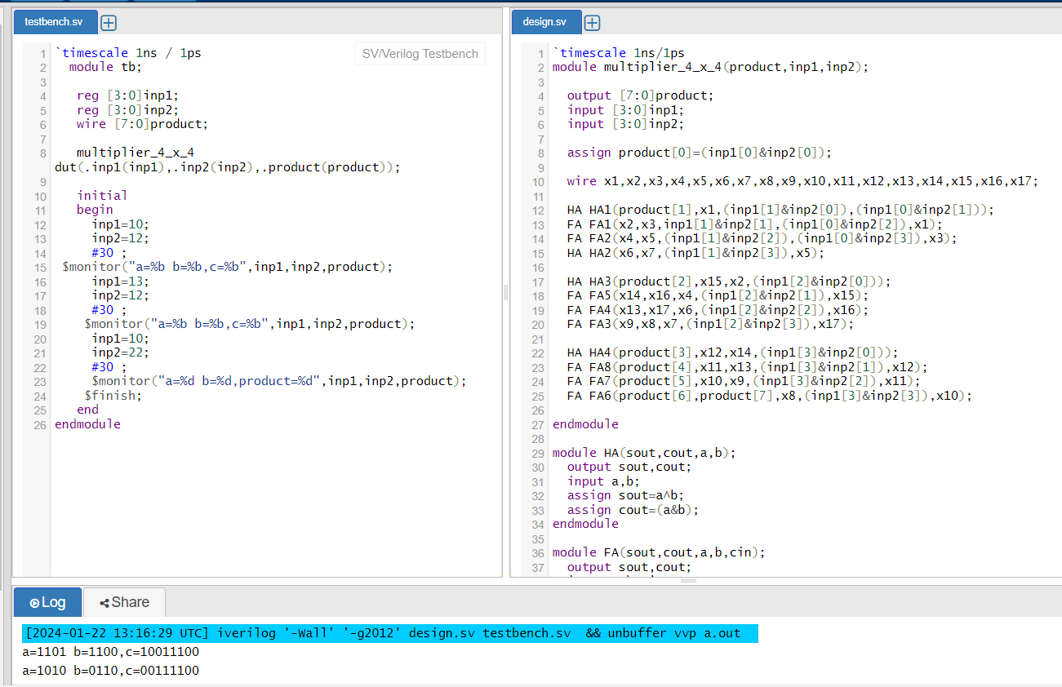

TASK 5 : Rising and Falling edge detector

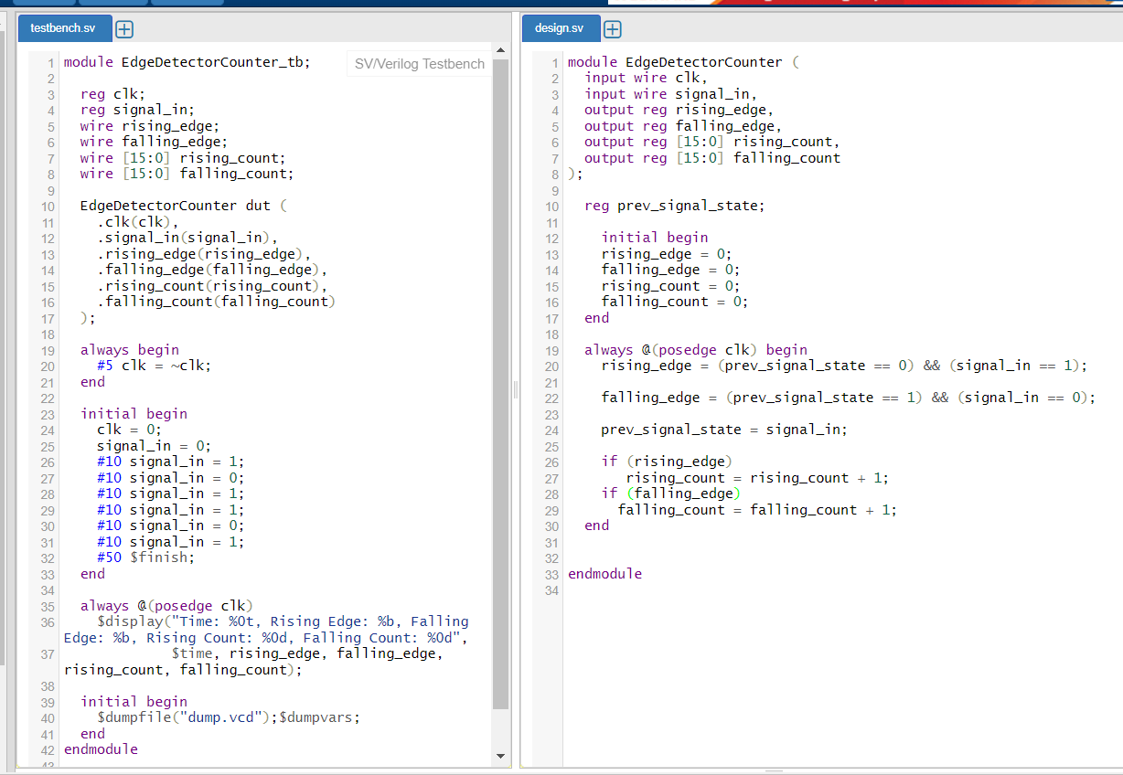

OUTPUT

